Project Development Phase Sprint III

|  |  |
| --- | --- |
| Date | 14 November 2022 |
| Team ID | PNT2022TMID40718 |
| Project Name | Signs with Smart Connectivity for better road safety |

**Sprint Targets :**

|  |  |  |  |  |  |  |
| --- | --- | --- | --- | --- | --- | --- |
| **Sprint** | **Functional Requirement**  **(Epic)** | **UserStory**  **Number** | **User Story / Task** | **Story Points** | **Priority** | **Team**  **Members** |
| Sprint-3 | Login | USN-5 | As an administrator , I should have an account of the  website | 7 | Low | K.Gayathri  G.Dhivya Bharathi  E.Shagithabanu  P.Khavya |
| Sprint-3 | Dashboard | USN-6SSS | As an admin , I should be able to monitor and add sign nodes | 13 | Medium | K.Gayathri  G.Dhivya Bharathi  E.Shagithabanu  P.Khavya |

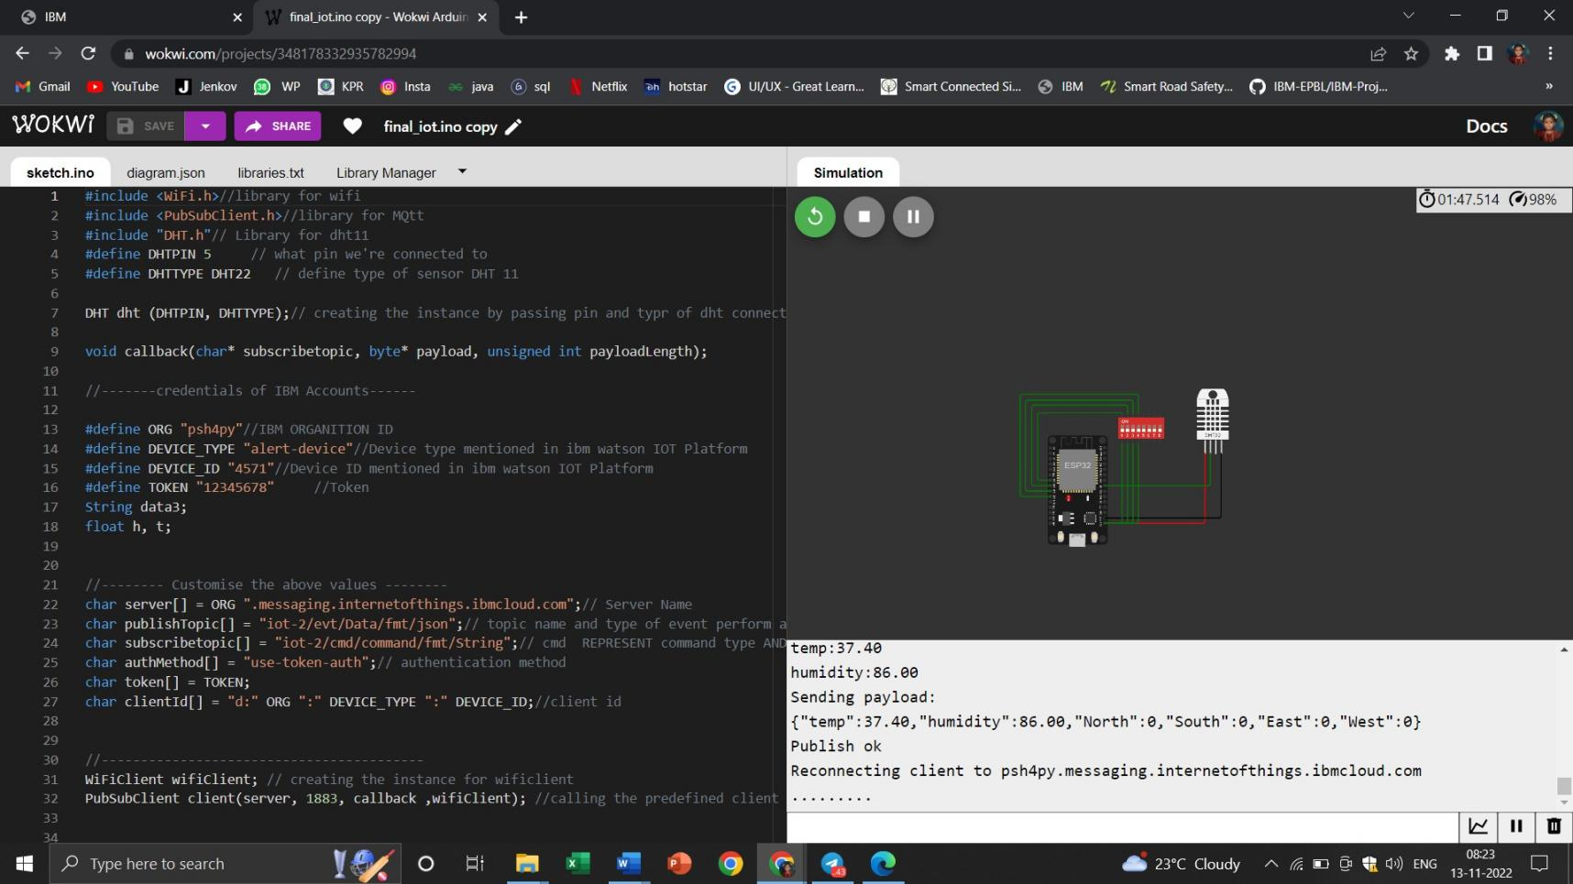

**IoT Device – IoT Platform**

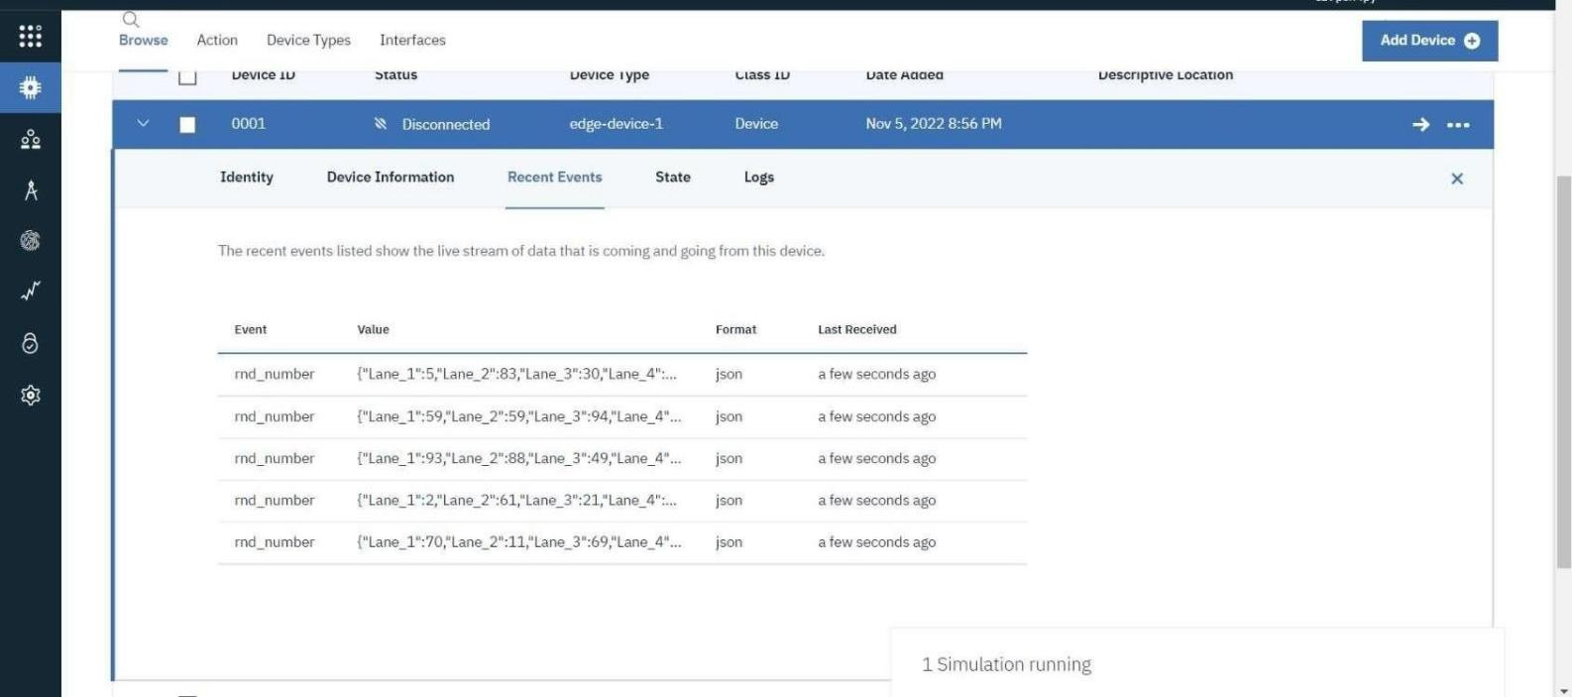

Node Red – Connect with MIT AppInventor

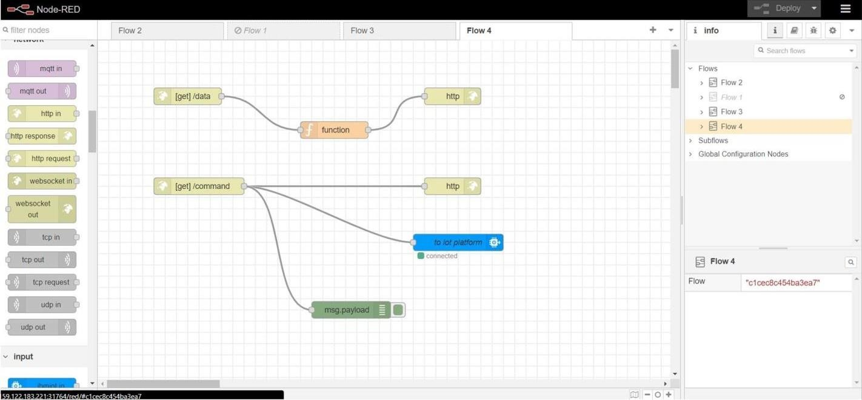

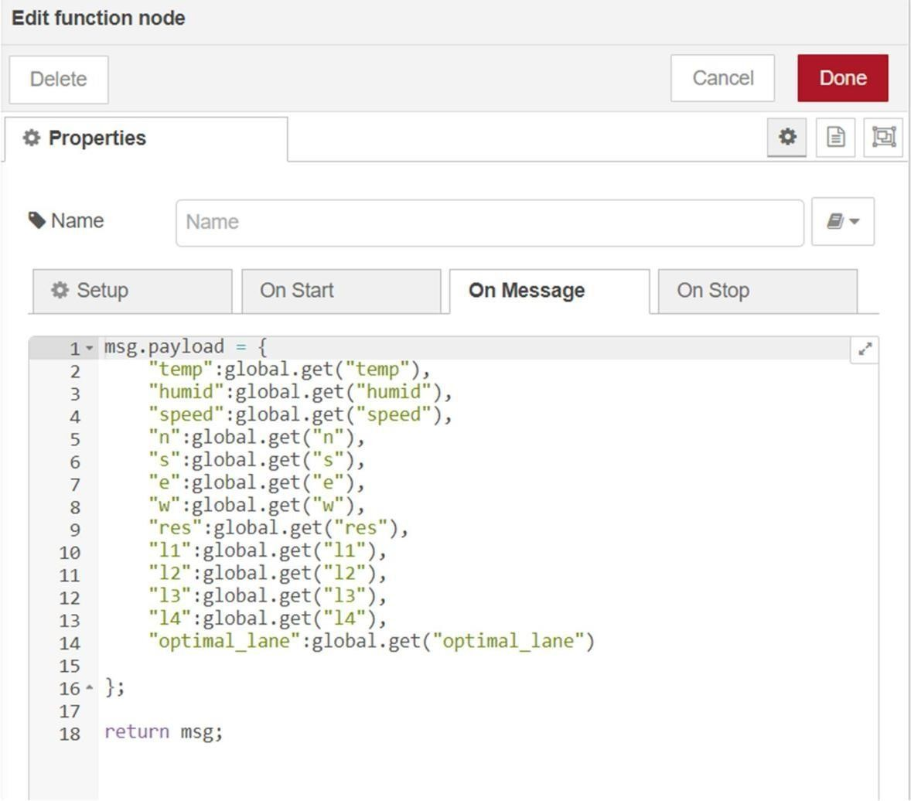

Output from Node red:

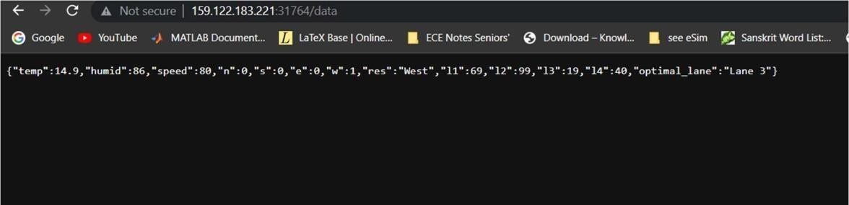

MIT App Inventor UI design:

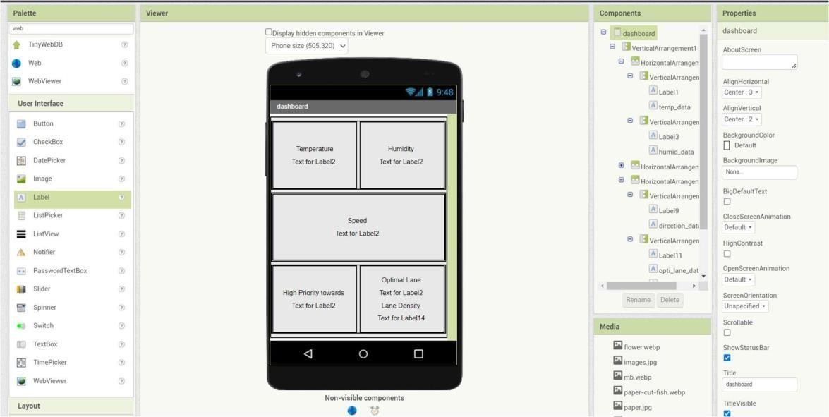

MIT App Inventor Backend design:

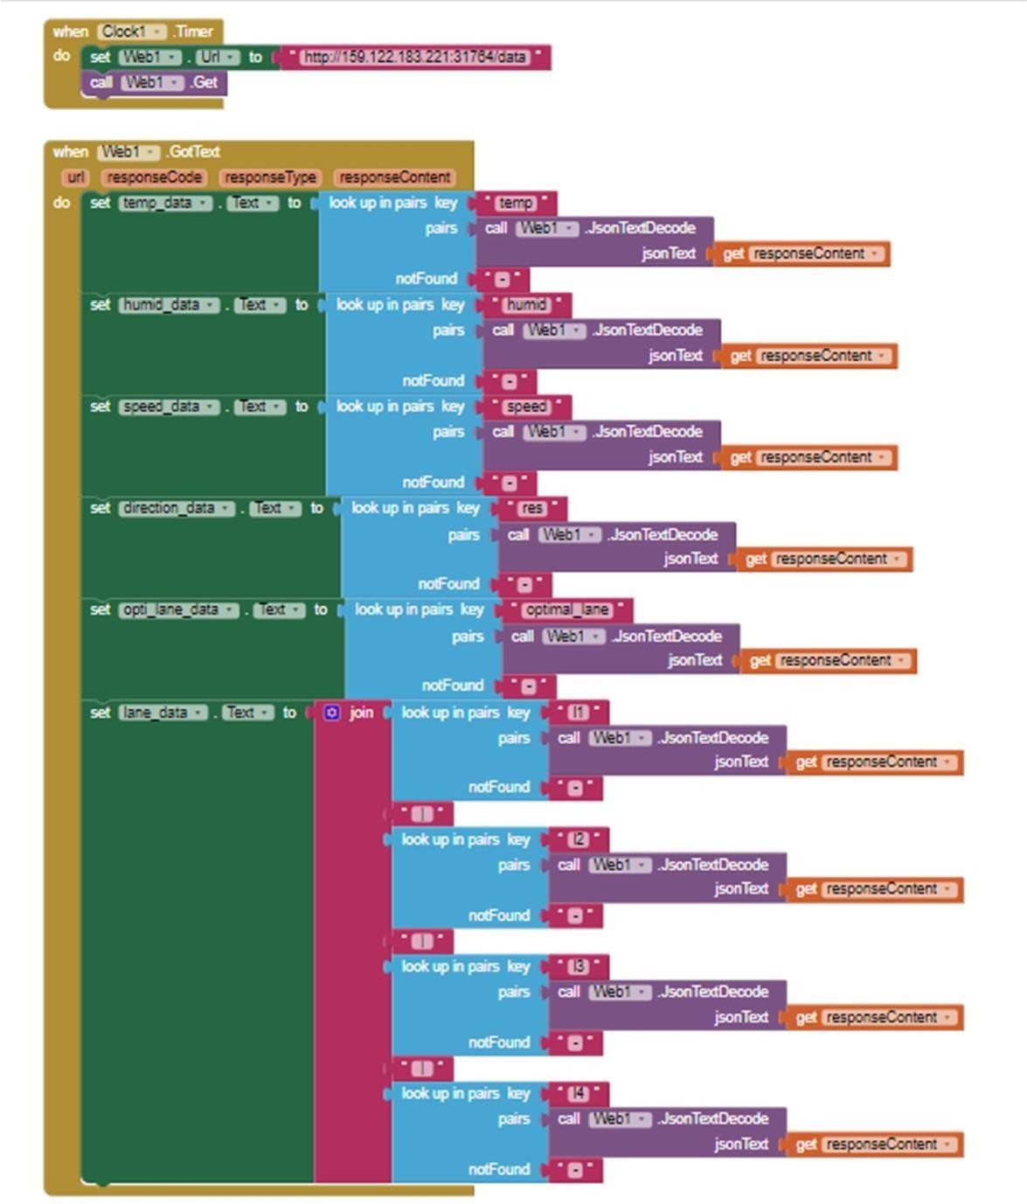

Sprint 3 delivery:

(OUTPUT) Display from MIT App:

